Toxicity ofCarbon Dioxide-Phosphine Combination To Tribolium Castaneum Inside Gastight BinsAnd Its Histological Effect On Albino Rats

Darwish, A. A.٭;Safaa, M. Halawa٭; EL-Lakwah, F. A. M.٭ ; Emam, M. A. ٭٭ and El-Gizawy, K. KH٭.

٭Plant Protection Dept., Faculty of Agric., Moshtohor, Benha University, Egypt.

٭٭ Histology and Cytology Dept., Faculty of Veterinary Medicine, Moshtohor, Benha University, Egypt.

Abstract
Toxicity of Carbon dioxide (30%), Phosphine (100 ppm) and their combination against the developmental stages of Tribolium castaneum(Herbst) (Coleoptera: Tenebrionidae)were studied under two degrees of temperatures20 and 30±2 °C, inside steel bins. The residual impact of the combination on the treated wheat was evaluated with respect to histological changes in different organs of rat fed on the treated wheat. Lethal time for 50, 90 and 99% (LT₅₀, LT₉₀ and LT₉₉) after exposure periods of 1,2,3 and 5 days were calculated. Results indicated that the pupaewere the least sensitive stage while the larvae were the most susceptible one to the combination. In addition, the mortalities of the different stages of T. castaneumin the combination treatment were higher than those obtained from each treatment alone. Histological examinationfor the rats feeding treated wheat with carbon dioxide-phosphine combination was done. Overall, testis, epididymis, stomach and spleen of the treated rats were not affected while liver; kidney and lung were affected through the appearance of mild histological changes. It may be concluded that this combination is good effective and less harmful in the case of control T. castaneum in the stored grains and recommended feeding of animals on these fumigated grains after 3 days from fumigation.

Key words: Stored grains, carbon dioxide-phosphine combination, fumigation, Tribolium castaneum, histological changes, rat.

Introduction

Insect pests of stored products are responsible for considerable economic losses to stored grains. Tribolium castaneum (Herbts) (Coleoptera :Tenebrionidae) is important pest of stored grains in Egypt. Presents secondary eating habits and is cosmopolitan, can attack different products, as flour, bran, feed, grain, biscuits, etc. Trematerra & Sciarretta (2004); Daglish (2006). Control of this insect relies heavily on the use of synthetic insecticides and fumigants, which has led to problems such as disturbances of the environment, increasing costs of application, pest resurgence, pest resistance to insecticides and lethal effects on non-target organisms in addition to direct toxicity to users Jembere et al.,(1995); Okonkwo and Okoye (1996) and El-Gizawy(2012).
Phosphine (PH₃) is the most popular fumigant in situations where rapid fumigations are not a priority. PH₃ has many advantages, it is effective against the most insect species on a very wide range, easy to use and apply, relatively inexpensive and most markets accept it as a residue free treatment. El-Lakwah (2001)showed that the dosage used of two-phosphine formulations was effective against the adults and immature stages of the tested insect species. However, the bio-toxicity of the gas was temperature and exposure period dependent. It was found that at 16-20°C grain temperatures, an exposure period of 7 days was required for complete mortality and this period was prolonged to 10 days when the temperature of the grain fell to from12 to 16°C.
Many studies were carried out whether fumigation treatments for stored product insects with different combinations of phosphine, Carbon dioxide and temperatures would be advantageous over PH₃ alone. Such studies involved use of gaseous mixtures of CO₂, ranging from low concentrations to almost 100 % with PH₃ as the remaining gas added at different temperatures. Several authors have suggested that the exposure period required to control insect pests with PH₃ could be reduced by combining it with CO₂, Athie et al., (1998); Desmarchelier (1984); Kashi and Bond (1975); Liang (1989); Mueller (1998); Rajendran (1989); Rajendran and Muthu (1989); Ren et al.,(1998); El-lakwah et al.,(2005) and Darwish (1998).
PH₃ are highly toxic to mammals World Health Organization(1988), including human Chugh et al., (1996); Anger et al.,(2000).PH₃ induces oxidative toxicity in many species Hsu et al., (2000); Chugh et al.,(1996); Anger et al.,(2000). Dua et al. (2010)have revealed that the brain and liver are two of the most susceptible tissues to phosphide toxicity, and an earlier study in which phosphide powder residue contaminated cowpea was fed to rats, revealed significant alterations in serum levels of hepatic indices.
The aim of the present study was to evaluate the effect of temperature on the toxicity of carbon dioxide; phosphine and their combination against the developmental stages of T. castaneumand identify the impact of 30% CO₂ and 100 ppm PH₃combination residue in wheat on histological changes in different rat organs.

Material and Methods

The experiments were conducted inside four gastight steel bins of 0.5 m³ volume. Each bin was filled with about 450 kg wheat grains. The bins were designed and constructed by the Military Factory for Airplanes at Helwan, Egypt. These bins were situated on the roof of the building of the Plant Protection Department at Faculty of Agriculture, Benha University.

- Insect culture
Tribolium castaneum was reared in glass container (250ml ) containing wheat flour covered with a fine mesh cloth for ventilation. The cultures were maintained in the dark in an incubator at 27 ± 2 ºC and 60 ± 5% RH. Adults were obtained from laboratory stock cultures maintained at the Plant Protection Dept. Faculty of Agric., Moshtohor, Benha University, Egypt.
The bioassay tests were carried out inside the gastight bins to prove the efficacy of gases in the different treatments against the developmental stages of Tribolium castaneumunder two degrees of temperatures 30±2 and 20±2 °C. Thirty adult of 7-14 days old insects, twenty eggs, thirty 4thinstar larvae and thirty pupae were used for fumigant toxicity tests.They wereintroducedto 50 g wheat flour in each cloth bag (10×16 cm). Each bag was closed well by a rubber band. Each treatment was replicated three times. Percentage of insect mortality was calculated using Abbott formula Abbott (1925). The fumigation of sub lethal-time of insect was done as described above, using the method with concentrations viz. LT₅₀ , LT₉₀ and LT₉₉after 1,2,3 and 5 days from treatment. Control binwasdone in the same way without gases.

- Fumigation bioassay:
  - Gases used:
Carbon dioxide was provided as pure gases of around 99.9% in pressure steel cylinders. Each cylinder was connected with a pressure regulator. Phosphine pellets, produced by Detia-DEGESCH, Germany were used during this study. One pellet weighs 0.6 g. and produced 0.2 g PH₃. CO₂ at concentration 30 ± 5%, PH₃ concentration at 100 ppm and combination of 30% CO₂ plus 100 ppm PH3 were used at two degrees of temperatures 20 and 30±2 °C, inside steel bins. against the various developmental stages of the tested insect.

  - Exposure procedure of the insects inside the bins:
Insect bags were inserted in the grains inside gastight steel bins just before each treatment. The cover of the bin was closed tightly. Grain temperature and the relative humidity inside the bins were recorded. After the exposure time, the bin was opened and aerated. Insect samples were then taken and transferred to the laboratory for mortality assessment.

  - Purging of the gases inside the bin:
CO₂: for obtaining 30% CO₂ concentration the cylinder of CO₂ was connected with the upper valve of the bin through a polyethylene tube, the valve of the cylinder was opened for about one minute and half, while the bottom valve of the bin was opened and closed after one minute from the initial purging of the gas.to measure the CO₂ conc. by using CO₂ gas analyser model 200-600 Gow-Mac-Instruments Company USA.
PH₃: After introducing the insect samples inside the grains, half phosphine pellet was put in a petri dish, which placed on the top of the grains. Then the cover and two valves of the bin were closed tightly. Measurements of PH₃ concentration inside the treated bins indicated that half pellet produced 100 ppm PH_{3.} A bin without treatment was used in this experiment as control. PH₃ concentration was measured using Draeger-gas detector tubes (50/a).

Histological study:
Twenty seven male Albino Wistar rats, weighing 150±25 g. were obtained from Rodents laboratory at Faculty of Agriculture, Moshtohor, Benha University. Experimental design and animal handling were approved by the Research Ethical Committee of Faculty of Veterinary Medicine, Benha University, Egypt. All efforts were made to minimize animal suffering.After one week acclimation period, rats were randomly assigned to two groups;first group fed on fumigant grain with combination of 30% carbon dioxide with 100 ppm phosphine for 5 days while the second group fed on untreated grain as control. Three replicates were carried out for each group. Specimens from vital organs (liver, kidney, spleen, testis, epididymis, lung and stomach) of treated male rats were collected at 1st; 3rd and 5th days after treatment. Specimens from these organs were taken at the same interval times from control rats for comparison. All specimens except testis were fixed in 10% neutral buffered formalin but tests were fixed in Bouin's fluid. The fixed specimens were dehydrated in ascending grades of ethyl alcohol, cleared in xylene, blocked in paraffin. Paraffin blocks were cut in sections of 5 micron thickness. Sections were stained with hematoxylin and euosin for general structure, periodic acid Schiff method for glycogen detection, and Masson's trichrome for identification of collagen fibers. All histological changes were examined and photographed by Leica microscope.

Results and discussion
Toxicity of 30% CO₂,100 ppm PH₃ and their combination of 30% carbon dioxide and 100 ppm phosphine were investigated against the developmental stages of Tribolium castaneum (Herbst.) under two degrees of temperatures 20 and 30±2 °C, inside gastight bins . The lethal insect exposure times of 50, 90 and 99% (LT₅₀, LT₉₀ and LT₉₉) after exposure period of 1,2,3 and 5 days were recorded (Table 1) .

- Toxicity of carbon dioxide:
The LT₅₀, LT₉₀ and LT₉₉ (days) for T. castaneum stages are shown in Table 1. The LT₅₀ at temperatures of 20 and 30 ° C was 6.43 and 2.63 days for eggs; 7.33 and 3.63 for the 4thinstar larvae; 10.07 and 5.25days for pupae and 6.37 and 3.68 days for adults. For LT₉₀, this variation was ranged from 32.22 to 6.81days for eggs; 27.57 to 10.4 days for the 4thinstar larvae; 37.77 to 22.48 days for pupae and 18.60 to 8.73 days for adults.Meanwhile, For LT₉₉, the reduction was ranged from 119.8 to 14.78 days for eggs; 81.21 to 22.98 days for the 4thinstar larvae; 111.01 to 73.59 days for pupae and 44.56 to 17.68 days for adults.
On the basis of LT₅₀ values andthe degree of temperatures inside gastight bins the sensitivity order of the developmental stages of T. castaneum to carbon dioxide was measured as: egg>adult >4thinstar larvae >pupae at 30% CO₂under the two degree of temperatures 20 and 30±2 °C, and 60±5% R.H.The higher temp. 30° C was more effective on the toxicity of the different stages of T. castaneumthan at 20° C.

- Toxicity of phosphine
The LT₅₀ values at 30° Cof eggs, larvae , pupae and adultswere 1.61, 1.27, 1.54 and 1.32 days, respectively to achieve 99% kill. These values increased to 6.68, 4.76, 7.40 and 4.36 days for the different stages, respectively.The adult stage of T. castaneumwas more susceptible to phosphine treatment than other insect stages. Nearly the same trend was recorded for the different stages of T. castaneum at20° C . Data in table (1) showed the time needed to obtain 50% and 99% kill for the various stages at the two degrees of temperatures (20 and 30±2°C), and 60±5% R.H. The4th instar larvae of T. castaneum were more susceptible to phosphine treatment, while the pupae was the most tolerant to the treatment of 100 ppm PH₃ at 20±2○C. because the nature of pupae which need to low amount of respiration.

- Toxicity of combined action of carbon dioxide and phosphine
Data in Table (1) showed the effect of 30% carbon dioxide conn. in an atmosphere of 100 ppm phosphineunder the two tested degrees of temperatures 20 and 30±2 °C, and 60±5% R.H. LT₅₀for egg, larva, pupa and adult stages, were 1.15, 0.90, 1.23 and 0.94 days at 30°C, respectively. The time to achieve 99% kill were 3.88, 4.67, 4.87 and 4.78 days for various stages, respectively. This result clearly indicates that pupae stage was the least sensitive to the combined action efficacy of 30 % CO₂plus 100 ppm phosphine at 30○C.Meanwhile, the results showed that the time needed to obtain 50% mortality for the different stages were 1.24, 1.20, 1.02 and 1.68 days for adult, egg, larvae and pupa, respectively. To achieve 99% kill, the days increased to 10.07, 36.60, 5.44 and 14.11 days for various stages, respectively. This result clearly indicates that the egg and pupae stages were the least sensitive to the combined of 30 % CO₂ with 100 ppm phosphine at 20○C
The results showed that the mortality percentage of the insects exposed to combination was higher than those obtained from each treatment alone and was more effective at 30ºC than at 20ºC against the various insect stages. Data achieved are in harmony with the results of Valizadegan (2011); Raimundo et al.,(2010);Ebrahime(2002) and El-lakwah et al.,(1989,1991 and 1992).
As the main route of entry ofthe fumigants in insects is the respiratory system, factors associated with its activity, such as temperature, may affect uptake fumigants (Chaudhry et al., 2004; Mitcham et al. 2006). Thus, the increased toxicity of carbon dioxide and phosphine combination with increasing temperature may occurred due to the increased rate of insects respiration having as a consequence a catchment most of the insecticide molecules.The major toxicity of the combination of carbon dioxide phosphine for the 4th instar larvae can also is associated with increasing respiratory rate. Emekci et al. (2002) observed that the respiratory rate of eggs, young and old larvae, pupae and adults of T. castaneum at 30°C, under normal atmospheric air was 0.32; 29.08; 3.33; 0.59 and 2.37 mg insect μl CO₂ h⁻¹, respectively.

- Histological studies of the effect of 30 % carbon dioxide with 100 ppm phosphine combination on rat organs.
Results showed that testis, epididymis, stomach and spleen of all rats fed on exposed grains to the combination were not affected and showed normal histological structures (Figs. 1-6). While, liver, kidney and lung were affected and showed histological changes in comparison to control rats.

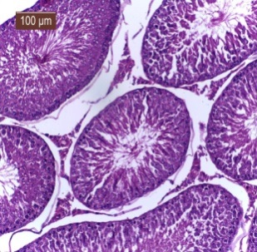
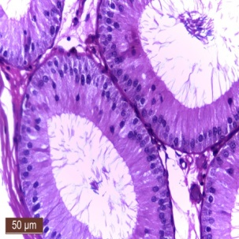

Table (1): lethal time values (days) and parameters of probit regression line estimated for different stages of T. castaneum exposed to 30% carbon dioxide; 100 ppm phosphine and their combination at 30 and 20±2○ C; 60±5% R.H.
Stage | Temp.  (°C) | LT₅₀ | LT₉₀ | LT₉₉ | Slop ±SD | R .
30% carbon dioxide
Egg | 20 | 6.43  5.51-7.51 | 32.22  22.92-45.29 | 119.80  68.87-208.39 | 1.83 ± 0.31 | 0.967
 | 30 | 2.63  2.35-2.95 | 6.81  5.80-7.99 | 14.78  11.53-19.18 | 3.10 ± 1.52 | 0.928
Larva | 20 | 7.33  6.42-8.37 | 27.57  20.99-36.23 | 81.21  52.49-125.65 | 2.22 ± 0.07 | 0.994
 | 30 | 3.63  3.27-4.04 | 10.04  8.59-11.73 | 22.98  17.89-30.53 | 2.90 ± 1.33 | 0.946
Pupa | 20 | 10.07  8.73-11.61 | 37.77  27.55-51.79 | 111.01  67.74-181.90 | 2.23 ± 0.04 | 0.996
 | 30 | 5.25  4.58-6.02 | 22.48  16.99-29.74 | 73.59  46.14-117.14 | 2.02 ± 0.14 | 0.986
Adult | 20 | 6.37  5.71-7.10 | 18.60  15.29-22.62 | 44.56  32.54-62.62 | 2.75 ± 0.08 | 0.995
 | 30 | 3.68  3.34-4.05 | 8.73  7.5-10.04 | 17.68  14.21-22.0 | 3.41 ± 1.02 | 0.969
100 ppm phosphine
Egg | 20 | 1.72  1.49-1.98 | 3.80  3.16-4.58 | 7.27  5.32-9.93 | 3.71 ± 1.51 | 0.895
 | 30 | 1.61  1.39-1.87 | 3.53  2.94-4.25 | 6.68  4.89-9.31 | 3.77 ± 1.11 | 0.921
Larva | 20 | 1.33  1.11-1.60 | 3.11  2.56-3.77 | 6.19  4.40-8.72 | 3.49 ± 0.72 | 0.938
 | 30 | 1.27  1.01-1.59 | 2.63  2.06-3.37 | 4.76  3.06-7.40 | 4.06 ± 1.40 | 0.868
Pupa | 20 | 1.80  1.56-2.08 | 4.03  3.35-4.85 | 7.75  5.69-10.55 | 3.67 ± 1.85 | 0.873
 | 30 | 1.54  1.30-1.82 | 3.65  3.01-4.44 | 7.40  5.27-10.39 | 3.41 ± 1.53 | 0.877
Adult | 20 | 1.68  1.45-1.96 | 3.81  3.17-4.58 | 7.41  5.42-10.13 | 3.62 ± 1.54 | 0.888
 | 30 | 1.32  1.08-1.60 | 2.55  2.02-3.21 | 4.36  2.93-6.49 | 4.48 ± 0.77 | 0.933
combination of 30% carbon dioxide and 100 ppm phosphine
Egg | 20 | 1.20  0.66-2.19 | 7.89  2.78-22.41 | 36.60  4.37-305.92 | 1.56±0.04 | 0.969
 | 30 | 1.15  0.88-1.50 | 2.49  1.94-3.19 | 4.67  2.93-7.44 | 3.82±1.27 | 0.865
Larva | 20 | 1.02  0.72-1.46 | 2.57  1.84-3.60 | 5.44  2.84-10.45 | 3.21±0.10 | 0.981
 | 30 | 0.90  0.58-1.40 | 2.29  1.73-3.03 | 4.87  2.70-8.79 | 3.18±1.59 | 0.790
Pupa | 20 | 1.68  1.25-2.26 | 5.43  3.22-9.17 | 14.11  5.47-36.39 | 2.52±0.01 | 0.995
 | 30 | 1.23  0.97-1.56 | 2.60  2.03-3.33 | 4.78  3.05-7.47 | 3.96±1.41 | 0.861
Adult | 20 | 1.24  0.86-1.78 | 3.93  2.49-6.02 | 10.07  4.15-24.39 | 2.55±0.06 | 0.981
 | 30 | 0.94  0.66-1.33 | 2.05  1.58-2.67 | 3.88  2.33-6.45 | 3.79± 0.39 | 0.951

R= Correlation Coefficient of regression line
SD= Standard deviation of the mortality regression line.

Fig:5

Fig:6

Fig. 1. Photomicrograph of treated rats with combination of CO₂ and PH₃ showing normal histological structure of testis. H&E stain.
Fig. 2. Photomicrograph of treated rats with combination of CO₂ and PH₃ showing normal histological structure of epididymis. H&E stain
Fig. 3. Photomicrograph of treated rats with combination of CO₂ and PH₃ showing normal histological structure of spleen. H&E stain
Fig. 4. Photomicrograph of treated rats with combination of CO₂ and PH₃ showing normal histological structure of stomach. H&E stain
Fig. 5. Photomicrograph of treated rats with combination of CO₂ and PH₃ showing normal distribution of PAS positivity in stomach in comparison to control stomach. PAS technique.
Fig. 6. Photomicrograph of treated rats with combination of CO₂ and PH₃ showing normal distribution of collagen fibers in lamina propria of stomach in comparison to control stomach. Masson’s trichrome stain

Liver:-
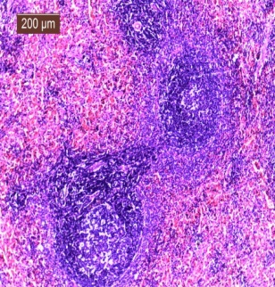
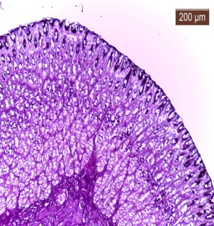
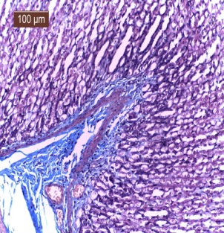
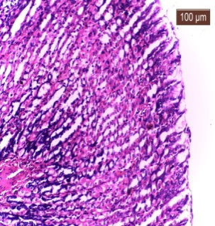
At 1st day after treatment, most of hepatocytes were enlarged with pale cytoplasm and darkly stained nuclei indicating hydropic degeneration (Fig. 7) but some normal hepatocytes were seen. At 3rd and 5th days after treatment, hepatocytes were still showing hydropic degeneration and central vein appeared dilated and congested (Fig. 8). These Livers showed no evidence for collagen fibers deposition (Fig. 9).
These histological changes in livers were recorded in comparison to normal histological structure of control liver where the hepatocytes arranged in cords radiating from central veins, blood sinusoids and portal area are seen (Fig. 10).
Fig:2
Fig:1
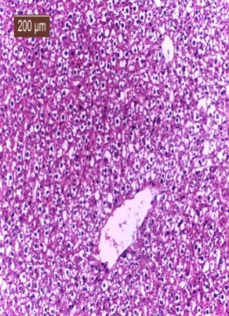
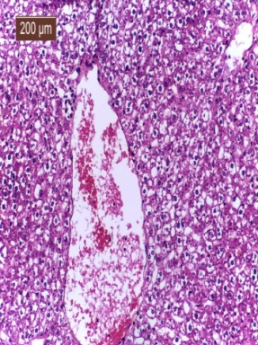
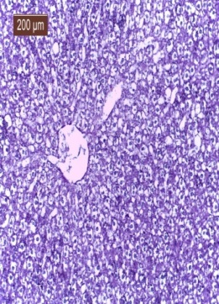
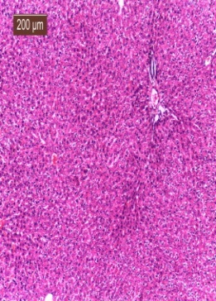
Fig:3
Fig:4

Fig:10

Fig:91

Fig:71

Fig:81

Fig. 7. Photomicrograph of liver of treated rats with combination of CO₂ and PH₃ at 1st day showing enlarged hepatocytes with pale cytoplasm and darkly stained nuclei (hydropic degeneration). H&E stain.
Fig. 8. Photomicrograph of liver of treated rats with combination of CO₂ and PH₃ at 3rd and 5th days showing hydropic degeneration in hepatocytes and dilated and congested central vein. H&E stain.
Fig. 9. Photomicrograph of liver of treated rats with combination of CO₂ and PH₃ showing no evidence for collagen fibers deposition (no cirrhosis). Masson’s trichrome stain.
Fig. 10. Photomicrograph of liver of control rats showing normal histological structure of liver where the hepatocytes arranged in cords radiating from central veins. H&E stain.

Kidney:-
At 1st day after treatment, renal tubules showed mild degenerative changes with clear lumen but intertubular hemorrhage were seen clearly (Fig. 11). At 3rd and 5th days after feeding, renal tubules showed moderate degenerative changes with degenerated materials in the lumen and the glomerulishowed small sizes (Fig. 12) in comparison to control kidney. Renal tubules in medulla of the kidney showed intertubular hemorrhage (Fig. 13).These histological changes in kidneys were recorded in comparison to normal histological structure of control kidney where the glomeruli showed normal size and feature, in addition, renal tubules showed intact epithelium and with clear lumen (Fig. 14).
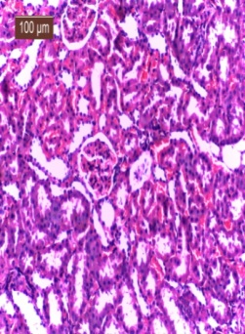
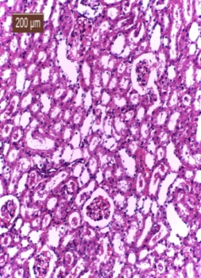
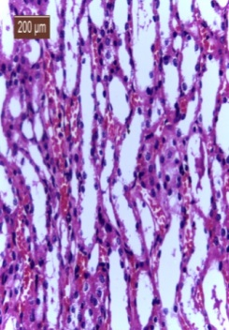
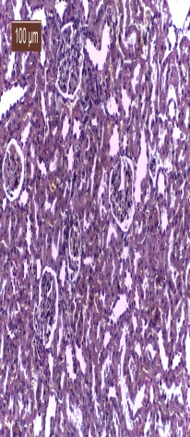
Fig. 15. Photomicrograph of lung of treated rats with combination of CO₂ and PH₃ at 1st day showing peri-bronchial mononuclear cellular aggregations. H&E stain.
Fig. 16. Photomicrograph of lung of treated rats with combination of CO₂ and PH₃ showing at 1st day showing perivascular mononuclear cellular aggregations. H&E stain.
Fig. 17. Photomicrograph of lung of treated rats with combination of CO₂ and PH₃ at 1st day showing dilated and congested blood vessels. H&E stain.
Fig:11
Fig:12
Fig. 18. Photomicrograph of lung of control rats showing normal lung structure. H&E stain.

Fig. 11. Photomicrograph of kidney of treated rats with combination of CO₂ and PH₃ at 1st day showing, mild degenerative changes in renal tubules with clear lumen in addition to severe intertubular hemorrhage. H&E stain.
Fig. 12. Photomicrograph of kidney of treated rats with combination of CO₂ and PH₃ at 3rd and 5th daysshowing moderate degenerative changes in renal
Fig. 13. Photomicrograph of kidney of treated rats with combination of CO₂ and PH₃ at 1st, 2nd, and 3rd days showing intertubular hemorrhage in medulla of the kidney. H&E stain
Fig. 14. Photomicrograph of kidney of control rats showing normal histological structure of kidney where the glomeruli showed normal size and feature, in addition, renal tubules showed intact epithelium and with clear lumen. Masson’s trichrome stain

Lung :-
The histological changes in lung were clearly seen at 1st day only. Peribronchial and perivascular mononuclear cellular aggregations were seen (Figs. 15,16), dilated and congested blood vessels were seen (Fig. 17). Such findings were in comparison to control lung where it showed normal alveoli, bronchioles and blood vessels (Fig. 18).

Our histological findings in liver, kidney and lung were in accordance with Sudakin and Power (2007); Turkez and Togar (2013) where they concluded that inhalation of phostoxin may cause severe pulmonary irritation leading to acute pulmonary edema, renal and hepatic damage. Such findings were appeared due to the ability of phostoxin to activate signals that increase necrosis factors that causes inflammation, malignancy and cell death Arora et al.,(1995); Sinha et al.,(2005); Saleki et al.,(2007).
Fig:14
Fig:13
In addition, Ozmen et al., (2009) and Mogilner et al., (2009) conducted the histological changes after exposure to CO₂ as a result of hypoxia and/or ischemia that lead to acute cellular swelling, cytoplasmic vacuoles, hydropic degeneration, focal hemorrhage and epithelial cells within the tubular lumens.

Conclusions
- The temperature affected toxicity of combination phosphine and carbon dioxide on all stages of T. castaneum development assessed.
- The toxicity of the combination of carbon dioxide and phosphine was higher than those obtained from each gas alone.
- The carbon dioxide is combined with the phosphine potential alternative to the use of conventional insecticides in tropical regions;
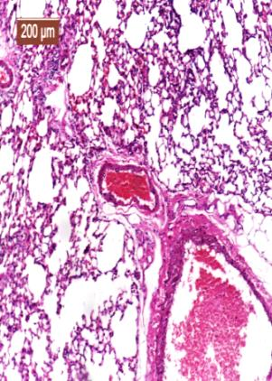
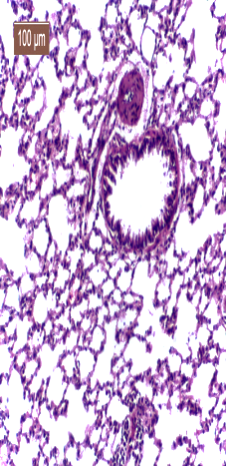
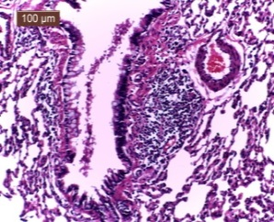
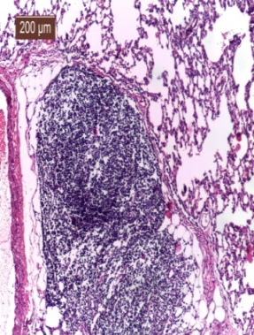
- The carbon dioxide is combined with the phosphine was effective and safe to control T. castaneum in the stored grains and recommended feeding of animals on these fumigated grains after 3 days from fumigation.
- The histological findings are reversible.

References
Fig:16

Fig:15

Abbott, W. S. (1925): A method of computing the effectiveness of insecticide. J. Econ. Ent. 18 (2), 265-267.
Anger, F.; Paysant, F. and Brousse, F. (2000): Fatal aluminum phosphide poisoning. J Anal Toxicol; 24:90–92.
Arora, B.; Punia, R.S.; Kalra, R.; Chugh, S.N.; Arora, D.R. (1995): Histopathological changes in aluminium phosphide poisoning. J. Indian Med. Assoc., 93(10):380-381.
Fig:17

Fig:17

Athie, I.; Gomez, R. A. R.; Bolonhezi, S.; Valentini, S. T. and De castro, M.F.P.M. (1998): Effects of carbon dioxide and phosphine mixtures on resistantpopulations of stored-grain insects. J. Stored Prod. Res., 34: 27-32.
Chaudhry, M. Q.; Bell, H. A.; Savvidou, N.; MacNicoll, A. D. (2004): Effect of low temperatures on the rate of respiration and uptake of phosphine in different life stages of the cigarette beetle Lasioderma serricorne (F.). J. Stored Products Res., 40(2):125-134.
Chugh, S.N., Arora, V., Sharma, A. and Chugh, K.(1996): Free radical scavengers & lipid peroxidation in acute aluminium phosphide poisoning. Indian J. Med. Res. 104,190–193.
Daglish, G. J.(2006): Survival and reproduction of Tribolium castaneum (Herbst), Rhyzopertha dominica (F.) and Sitophilus oryzae (L.) following periods of starvation. Journal of Stored Products Research, 42(3):328-338.
Darwish A.A. (1998):Role of CO₂ on the toxicity of phosphine to larvae of two stored product insects . Annals of Agric. Sci. , Moshtohor , 1269-1285 .
Desmarchelier, J. M. (1984): Effect of carbon dioxide on the efficacy of phosphine against different stored product insects. Mitteilung aus der biologichen bundesanstalt for landund porstwirtschaft –berlin heft. (5): 360–368.
Dua, R.; Sunkaria, A.; Kumar, V. and Gill, K.D.(2010): Impaired mitochondrial energy metabolism and kinetic properties of cytochrome oxidase following acute aluminium phosphide exposure in rat liver. Food and Chemical Toxicology.;48(1):53–60.
E1-Lakwah, F. A.; Azab, M. M. and Gaaboub, I. A. (2005): Interactive effects of phosphine, temperature and exposure time on the complete mortality of two stored product insects. Alex. J. Agric. Res. 50(2):171-175.
El-Gizawy, K. KH. (2012): Studies on effectiveness of some plant extracts and dusts against certain stored product insects. M. Sc. Thesis, Fac. Agric. Banha Univ., Egypt.
EL-Lakwah, F. A. M.; Abdel-Gawaad, A.; Meusr, F.; Wohlemuth, R. and Darwish, A. (1992): Efficiency of phosphine alone and in mixtures with carbon dioxide against the adults of Tribolium castaneum and Sitophilus oryzae. J. appl. Sci., 4(2):527-545.
El-Lakwah, F., Meuser, F., Abdel G. A., Wohlgemuth, R., Darwish, A.(1991): Efficiency of phosphine alone and mixtures with carbon dioxideagainst Angoumis grain moth Sitotroga cerealella (Oliver) (Lepidoptera: Gelechiidae). J. Plant Diseases Prod. 98:92-102.
El-Lakwah, F.A. M. (2001): Trials on the use of phosphine gas as alternative of methyl bromide for fumigation of wheat grains in the concrete silos in Egypt. Annals of Agric. Sc., Moshlohor, 39(3): 1823-1839.
El-Lakwah, F.A., Wohlgemuth, R. and Khattab, M.M. (1989) Efficiency of phosphine with carbon dioxide against Khapra Beetle larvae Trogoderma granarium Everts. (Col., Dermestidae). Anz. Schadlingskde., Pflanzenschutz, Umweltschutz, 62:85-88.
Emekci, M.; Navarro, S.; Donahaye, E.; Rindner, M. and Azrieli, A.(2002):Respiration of Tribolium castaneum (Herbst) at reduced oxygen concentrations. J. Stored. Prod. Res., 38(5):413-425.
Hsu, A.L.; Ching, T.T.; Wang, D.S.; Song X.; Rangnekar V.M. and Chen, C.S.(2000): The cyclo-oxygenase-2 inhibitor celecoxib induces apoptosis by blocking Akt activation in human prostate cancer cells independently of Bcl-2. J. Biol. Chem. 275:11397–11403.
Jembere B., Obeng-Ofori D., Hassanali A. and Nyamasyo G.N.N. (1995): Products derived from the leaves of Ocimum kilimanndscharicum (Labiatae) as post-harvest grain protectants against the infestation of three major stored product insect pests. Bull. Entomol. Res. 85: 361–367.
Kashi, K.P. and Bond, E.J. (1975): The toxic action of phosphine: role of carbon dioxide on the toxicity of phosphine to Sitophilus granarius (L.) and Tribolium confusum DuVal. J. stored Prod. Res., 11: 9-15.
Liang, Q. (1989): The current status of fumigation and controlled atmosphere storage technologies in China. In: Fumigation and Controlled Atmosphere Storage of Grain:Proc. Int. Conf. (Edited by Champ, B.R., Highley, E., and Banks, H.J.) Singapore, 14-18 Feb. 1989 ACIAR Proceedings 25: 166-173.
Mitcham, E.; Martin, T. and Zhou, S. (2006): The mode of action of insecticidal controlled atmospheres. Bulletin of Entomological Research, 96(3):213-222.
Mogilner , J.; Sukhotnik, I.; Brod, V.; Hayari, L.; Coran, A.G.C.; Shiloni, E.; Eldar, S. and Bitterman, A. (2009): Effect of elevated intra-abdominal pressure on portal vein and superior mesenteric artery blood flow in a rat. J. Laparoendosc Adv Surg Tech A.;19 Suppl1:S59-S62.
Mueller, D. K. (1998): A new method of using low levels of phosphine in combination with heat and carbon dioxide. In: Stored Grain in Australia. Proceedings of the AustralianPostharvest Technical Conference, (Edited by Banks, H.J, Wright, E.J and Damcevski, K.A.), 123-125.
Okonkwo, E. U., and Okoye, W. I. (1996): The efficacy of four seed powders and the essential oils as protectants of cowpea and maize grains against infestation by Callosobruchus maculatus and Sitophilus zeamais. Nigeria International Journal Pest Management, 42 (3):143-146.
Ozmen, M.M.; Zulfikaroglu, B.; Besler, T.H.; Cinel, L. and Cinel, I. (2009): The correlation between reactive oxygen species and histopathology of the liver, gut, and kidneys in animals with elevated intra-abdominal pressure. J. Laparoendosc Adv. Surg. Tech. A,19: 339-343.
Raimundo, W. S. Aguiar; Lêda, R. D’A. Faroni; Raul, N. C. Guedes; Adalberto, H. Sousa and Adriano, F. Rozado (2010): Toxicity of the carbon dioxide and phosphine combination to Tribolium castaneum under different temperatures. Revista Brasileira de Engenharia Agrícola e Ambiental, 14(8):881–886.
Rajendran, S. (1989): The toxic action of phosphine, methyl bromide, methyl chloroform, and carbon dioxide, alone and as mixtures, against the pupae of Tribolium castaneum Herbst (Coleoptera: Tenebrionidae). In: Fumigation and Controlled AtmosphereStorage of Grain: Proc. Int. Conf. (Edited by Champ, B.R., Highley, E., and Banks, H.J.) 25: 273-274.
Rajendran, S. and Muthu, M. (1989): The toxic action of phosphine in combination with some alkylhalide fumigants and carbon dioxide against the eggs of Tribolium castaneum Herbst (Coleoptera: Tenebrionidae). J. stored Prod. Res., 25, 225-230.
Ren, Y. L., O’Brien, I. G. and Whittle, C. P. (1998): Studies on the effect of carbon dioxide in insect treatment with phosphine. In: Stored Grain in Australia. Proceedings of theAustralian Postharvest Technical Conference, (Edited by Banks, H.J, Wright, E.J and Damcevski, K.A.), Canberra 26-29 May 1998. 173-177.
Saleki, S.; Ardalan, F.A. and Javidan-Nejad, A. (2007): Liver histopathology of fatal phosphine poisoning. Forensic Sci Int, 166(2-3):190-193.
Sinha, U.S.; Kapoor, A.K.; Singh, A.K.; Gupta, A.; Mehrotra, R. (2005): Histopathological changes in cases of aluminium phosphide poisoning. Indian J PatholMicrobiol., 48(2):177-180.
Sudakin, D. L. and Power, L. E. (2007): Organophosphate exposures in the United States: a longitudinal analysis of incidents reported to poison centers. J. Toxicol Environ Health. 70(2):141-147.
Trematerra, P. and Sciarretta, A.(2004): Spatial distribution of some beetles infesting a feed mill with spatio-temporal dynamics of Oryzaephilus surinamensis, Tribolium castaneum and Tribolium confusum. J. Stored Prod. Res., 40(4):363-377.
Türkez, H. and Togar, B. (2013): Aluminium phosphide-induced genetic and oxidative damages in vitro: attenuation by Laurusnobilis L. leaf extract. Indian J. Pharmacol.45(1):71-75.
Valizadegan, O. (2011): The impact of carbon dioxide in stored-product insect treatment with phosphine African J. Biotechnology 11(23): 6377-6382.
Ebrahim, Wesam, M. K. (2002): Studies on effectiveness of certain methyl bromide alternative against some stored product insects in gastight bins. Ph. D. Dissertation, Moshtohor Fac. Agric., Zagazig Univ., Benha branch, Egypt.

سمية مخلوط غاز ثاني اكسيد الكربون والفوسفين ضد حشرة خنفساء الدقيق الصدئية في الصوامع محكمة الغلقوتأثيره الهستولوجي على الفئران

أ.د/ أحمد عبد الغفار درويش٭، أ.د/ صفاء محمود حلاوة٭، أ.د/ فارس امين اللقوة٭، د/ محمود عبد الغفار أمام،
أ / كرم خميس الجيزاوي

قسم وقاية النبات – كلية الزراعة بمشتهر – جامعة بنها – مصر
قسم الانسجة والخلايا – كلية الطب البيطري بمشتهر – جامعة بنها – مصر

اجرى هذا البحث بغرض دراسة سمية غاز ثاني اكسيد الكربون وغاز الفوسفين وكذلك مخلوط الغازين معا ضد الاطوار المختلفة لحشرة خنفساء الدقيق الصدئية واجريت التجارب داخل صوامع من الصلب محكمة الغلق ومملؤة بحوالي 450 كيلو جرام من القمح. وصممت هذه الصوامع بالمصنع الحربى بحلوان، ووضعت على سطح مبنى قسم وقاية النبات بكلية الزراعة بمشتهر واجريت المعاملات المختلفة على درجتي حرارة 30، 20± 2م° ورطوبة نسبية60±5%. علاوة على ذلك تم تقييم التأثير الباقيلمخلوط مكون من 30% غاز ثاني اكسيد الكربون و100 جزء بالمليون من غاز الفوسفين على التغيرات الهستولوجية للأجهزة المختلفة للفئران. وبتقدير الوقت اللازم لقتل 50، 90, 99 % من الحشرات بعد فترة تعريض 1، 2، 3، 5 ايام اشارت النتائج الى ان فاعلية كل من غاز ثاني اكسيد الكربون وغاز الفوسفين وكذلك مخلوط الغازين كانت اكثر فاعلية على درجة الحرارة المرتفعة عنه في درجة الحرارة المنخفضة وان طور العذراء هو الاقل حساسية بينما طور اليرقة هو الاكثر حساسية لمخلوط الغازين، بالإضافة الى ان نسبة الموت المتحصل عليها لمخلوط الغاز في المراحل المختلفة لحشرة خنفساء الدقيق الصدئية كان اعلى من تلك التي تم الحصول عليها من كل غاز على حده. كما اظهرت نتائج تقييم التأثيرات الهستولوجية للفئران التي غذيت على حبوب القمح المعاملة بمخلوط الغازين الى ان كل من الخصية والبربخ والمعدة والطحال لم تتأثر بشكل عام في حين ظهرت بعض التغيرات الهستولوجية الخفيفة على كل من الكبد والكلى والرئة. وتوصلت هذه الدراسة الى ان استخدام مخلوط غازي ثاني اكسيد الكربون والفوسفين لمكافحة حشرة خنفساء الدقيق الصدئية بالحبوب المخزونة هي طريقة فعالة وامنة كما توصى هذه الدراسة بتغذية الحيوانات على الحبوب المبخرة بذلك المخلوط بعد 3 ايام من المعاملة.

